CEG
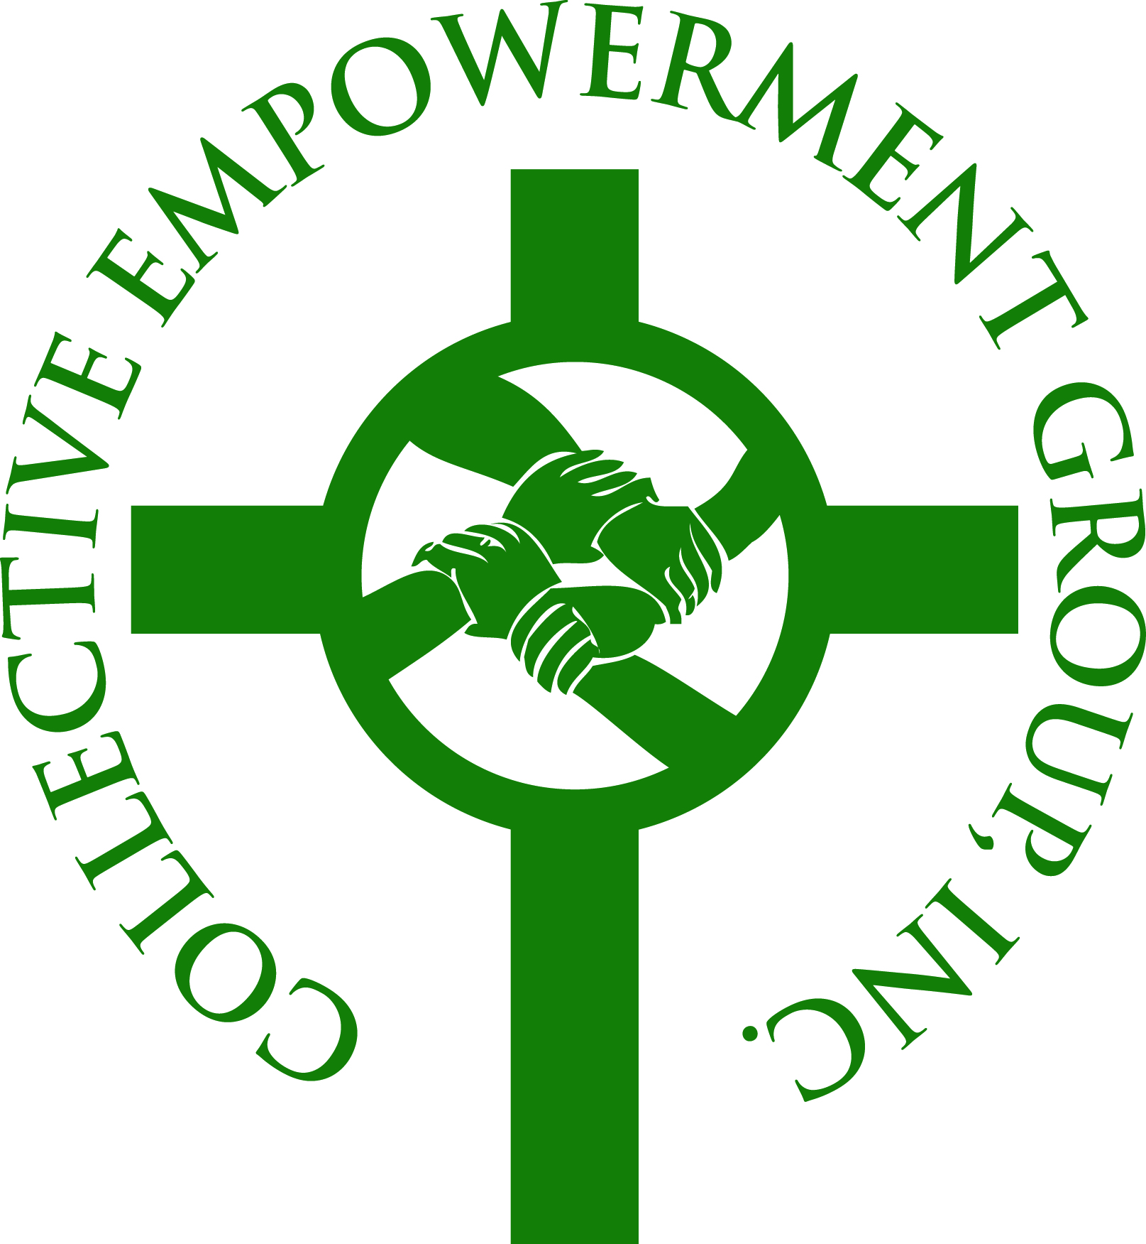
The Collective Empowerment Group, Inc.
(formerly The Collective Banking Group, Inc.)

Live up to
Expectations
And
Deliver
___________________________________________________________________________________________________________________________________________________________________

STRATEGIC PARTNER APPLICATION CHECKLIST

 | 1. | Briefly tell us about yourself and the services of your Business/Organization.
 | 2. | How is your Organization Structured and give a brief description or your Management Team (Bio’s)
 | 3. | List in detail why you believe that the Collective Empowerment Group is the right fit for your organization, and clearly articulate what you have to offer the CEG?
 | 4. | Describe what you see as the ideal win-win situation.
 | 5. | Complete and sign the Enclosed Application
 | 6. | Upon acceptance, Sign the Strategic Partnership Agreement and Pay Membership Fee.  Mail your check to:  The Collective Empowerment Group, Inc.  9701 Apollo Drive, #447  Upper Marlboro, MD 20774

Strategic Partner Roles & Responsibilities Agreement

The following guidelines outline the requirements to becoming and maintaining your status as a strategic partner of the Collective Empowerment Group, Inc.

To be a Strategic Partner of The Collective Empowerment Group, Inc., the following commitments are required:

- Pay a membership dues fee of $500.00 - $5,000 per year depending upon Partnership Level.
- Documented reduced fees for Collective Empowerment Group Churches and/or Church members.
- You or your representative to attend at least 50% of the monthly general meetings held on the 1st Friday of each month.
- Participate in all annual events, conferences and meetings.

The Collective Empowerment Group will provide you with:

- Access to our member churches and pastors.
- Unprecedented marketing opportunities to our 200,000+ constituents.
- The privilege of advertising in the quarterly church newsletters at a reduced rate (where appropriate).
- The opportunity to conduct special programs and client gathering sessions at our member churches.
- The ability to conduct seminars as a part of our speaker quarterly forums.
- Key speaker role and presence at CEG annual conference.

ACCEPTED:

______________________________ ________________________
Applicant Date

STRATEGIC PARTNER APPLICATION

Date:
ABOUT YOUR COMPANY
Name of Business:
Street Address:
City/State/Zip:
 |  | Business: |  | Cellular: |  |  | Fax:
Telephone #’s:
Website/E-mail:
Date of Incorporation:
Legal Structure
Year(s) in Present Location: |  |  |  |  | Year Founded:
ABOUT THE STAFF
Number of paid staff:
Top 3 Managers: |  |  | Name: |  | Telephone #: |  |  | Time in Position:
President/CEO:
COO:
CFO:
# Of Total Staff:
Collective Empowerment Group, Inc.
Summarize the nature of your business and why you want to become a Strategic Partner. State how the CEG member churches will benefit by your company becoming a Strategic Partner.

Applicant’s Declaration and Authorization:

I hereby certify that my answers to the questions appearing in this Strategic Partner Application are true and complete.
I hereby authorize The Collective Empowerment Group to conduct a background check on the business, which may include a Dunn & Bradstreet report and /or reports from other such business reporting agencies.

____________ _________
Signature Date

Please sign and return to:

The Collective Empowerment Group, Inc.
9701 Apollo Drive, 447
Upper Marlboro, MD 20774

__________________________________________ ___________________________
Signature of Applicant Date

Please attach the following materials:
- Corporate Brochure
- Copies of Achievement Awards
- Company Newsletter (if available)
- Biography of Principals
- Other material you feel appropriate

Please indicate requested level of partnership:

_______ Platinum Partner $5,000.00

_______Gold Partner $2,500.00

_______Bronze Partner $1,000.00

_______Associate Partner/Non-Profit



The Collective Empowerment Group, Inc.

Live up to
Expectations
And
Deliver

Strategic Partnership Levels

$5,000.00 – Platinum Partner
- 20-minute presentation before the Board of Directors
- Attend all Meetings and Programs
- 2 10-minute presentations at the General Membership Meeting
- Link on CEG Website
- Full-page Color Ad in all Souvenir Journals
- Corporate name displayed at Conference and MLK
- Exhibit opportunities at the MLK, Conference, Golf Tournament and Gala Breakfast
- Gold Sponsorship of the CEG Gala Breakfast:
10-minute presentation at the Breakfast
Reserved table of ten with signage
Corporate name and logo displayed at Breakfast
Quote from CEO in the Breakfast Press Release
Corporate logo on CEG promotional materials

$2,500.00 – Gold Partner
- Attend all Meetings and Programs
- 1 5-minute Presentation at the General Membership Meeting
- Link on the CEG Website
- Full-page Ad in all Souvenir Journals
- Exhibit opportunities at the MLK, Conference and Gala Breakfast
- Gold Sponsorship of the CEG Empowerment Conference:
Sponsorship of Conference Luncheon
5-minute Presentation at the Conference
Reserved table of ten with signage at Conference Luncheon
Corporate logo displayed at the luncheon
Corporate logo on promotional materials

$1,000.00 – Bronze Partner
- Attend all Meetings
- 1 5-minute Presentation at the General Membership Meeting
- Link on CEG Website
- ½ Page Ad in the Gala Souvenir Journal
- Exhibit opportunities at the MLK and Gala
- Hole Sponsorship at the Golf Event
- 10-minute Presentation at the Golf Event

$500.00 – Associate Partner/Non-Profit
- Attend all Meetings
- Link on the CEG Website

