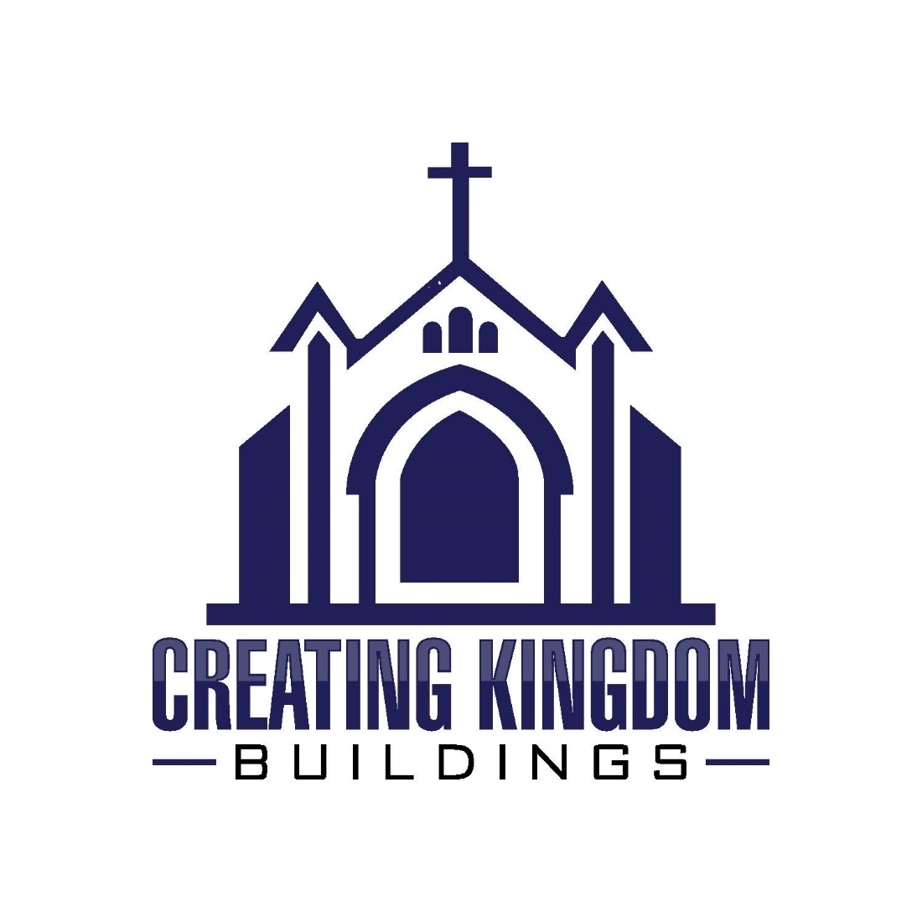
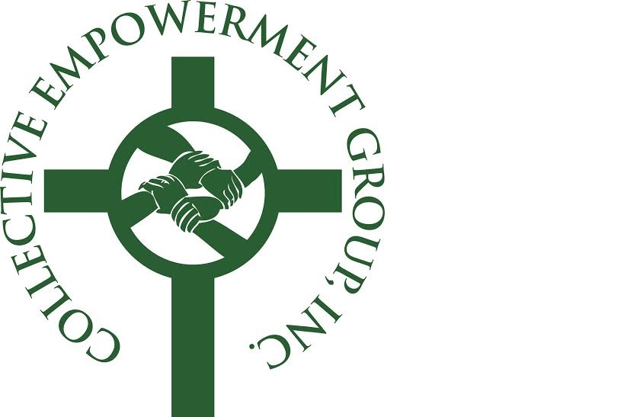

Creating Kingdom Buildings Conference
Saturday, April 30, 2016
The Sanctuary At Kingdom Square
9033 Central Avenue – Capitol Heights, MD
NON-SPONSORSHIP ADVERTISING OPPORTUNITIES

Back Cover $500.00
(subject to availability)

Inside Front Cover $350.00
Inside Back Cover $350.00
Full Page $150.00
Half-Page $100.00
Quarter-Page $ 75.00
Ad Specifications:
(All ads are color)
Covers and full page – 8 ½w x 11h
Half-page - 8 ½ w x 5.5 h
Quarter page – 4 x 5 h
Please submit ad in PDF or JPEG format, via email to:
CollectiveEmpowermentGroup@gmail.com
Deadline to submit ads: Monday, April 18, 2016
Please send check(s), payable to Collective Empowerment Group, to:
Collective Empowerment Group, Inc.
9701 Apollo Drive, #447
Upper Marlboro, MD 20774

Or pay online at CollectiveEmpowermentGroup.org
Thank You for Your Support!

SPONSORSHIP ADVERTISING
(Included with Sponsorship)

Platinum Sponsors – Full Page Ad
Gold Sponsors – Half-Page Ad
Silver and Bronze Sponsors – Quarter-Page Ad

