Collective Empowerment Group, In
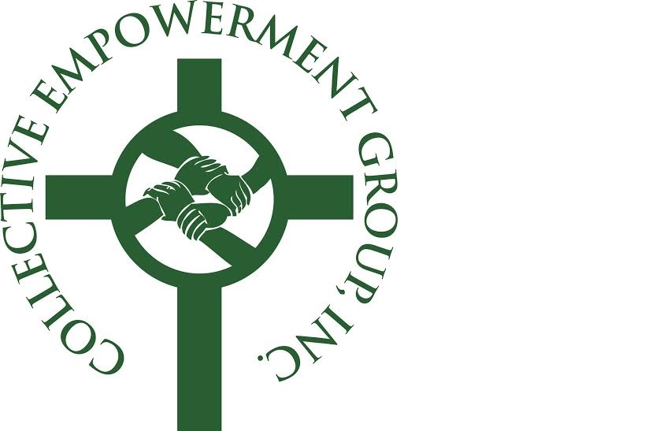
21st Anniversary Awards Breakfast
Saturday, December 3, 2016
9a.m. - 12p.m.
EARLY BIRD TICKET SPECIAL!
$65.00 PER PERSON IF PAID BY
OCTOBER 14, 2016!

The Camelot - Upper Marlboro, MD
$67.50 per person CEG Members * $75.00 per person Non-Members
Youth-Young Adult (to age 35) $60.75 per person
Table of Ten: $675.00 CEG Members * $750.00 Non-Members
Free Full-Page Ad With Purchase of 2 or more Tables
Purchase on-line at www.CollectiveEmpowermentGroup.org
~ SPONSORSHIP OPPORTUNITIES ~

I. Title/Co- Sponsor $15,000.00 IV. Gold Sponsor $5,000.00

- Co-Sponsor the Breakfast with the CEG
- Co-presenter of Youth Minister awards at Breakfast
- Quote from CEO in press release and on screen

- 2 reserved seats at head table

- 7-10-minute live remarks during the Breakfast

- Exhibit opportunity at 2017 monthly General Meeting

- Exhibit tables at Breakfast, and 2017 Empowerment Conference and Golf Tournament

- Corporate name displayed at the Breakfast, and 2017 Empowerment Conference
- 2 reserved tables of ten with signage
- Cover ad in Breakfast souvenir journal

- Photo-op with CEG President

- Link and logo on CEG website for one year
- Encore 10-min presentation at one CEG monthly meeting
- Present workshop at 2017 Empowerment Conference

II. Platinum Sponsor $10,000.00

- Quote from CEO in press release

- Corporate name displayed at the Breakfast

- Full-page color ad in Breakfast souvenir journal

- Reserved table of ten with signage

- Exhibit opportunities at the 2017 Golf Tournament

- Corporate name displayed at the 2017 Empowerment Conference
- Presenter at the 2017 Empowerment Conference

V. Silver Sponsor | $3,000.00

- Corporate name displayed at the Breakfast

- Reserved table of ten with signage

- Full page color ad in Breakfast souvenir journal

VI. Bronze Sponsor | $1,500.00  -Corporate name displayed at the Breakfast  - Five reserved seats  - Half -page color ad in Breakfast souvenir journal and 2017 Empowerment Conference Journal  Non-Sponsorship Exhibitor - 6ft. Table  - $250.00 per table – Non-Members (1 meal included - additional Exhibitor Meal $65.00)  - $125.00 per table – Members and Partners  - $100.00 per table - Honorees

- 2 Reserved Seats at Head Table

- 3-5-minute video remarks during the Breakfast
- Corporate name displayed at the Breakfast and 2017 Empowerment Conference and Golf Tournament
- 2 reserved tables of ten with signage

- Link & logo on CEG Website 6 months

- 2-page ad in Breakfast souvenir journal

- Color Cover Ad | $ 500.00
(Subject to availability)
-2-Page Color Ad | $ 500.00
-Non-Member Full-Page Ad 8 ½ x 11 | $250.00
-Non-member Half-Page Ad 5.5 x 8 1/2 | $ 150.00
-Member & Partner Full-Page Ad 8 ½ x 11 | $ 150.00
Member & Partner Half-Page Ad 5.5x8 12 | $100.00
- Exhibit opportunities at the 2017 Empowerment Conference and Golf Tournament
- Present workshop at the 2017 Empowerment Conference

III. Diamond Sponsor | $7,500.00

- Corporate introduction at the Breakfast
- Corporate name displayed at the Breakfast

- Reserved table of ten with signage

- Full page color ad in Breakfast souvenir journal

- Exhibit opportunities at the 2017 Empowerment Conference and Golf Tournament

Non-Sponsorship Advertising
Rev. Marcellous Buckner, President
301-699-8449 www.CollectiveEmpowermentGroup.org CollectiveEpowermentGroup@gmail.com

