Collective Empowerment Group, Inc.
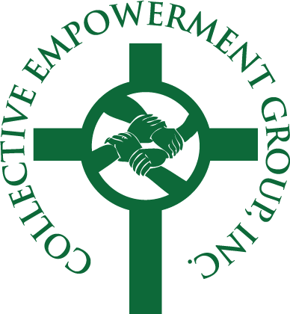
Empowerment Conference
Evangel Assembly of God
5900 Old Branch Avenue – Temple Hills, MD
Reverend Dr. St. Clair Mitchell, Host Pastor
Rev Anthony G. Maclin, President

Saturday, June 6, 2015 Empowerment Conference
8:00a.m. – 9:00a.m. Registration and Continental Breakfast
9:00a.m. – 10:30a.m. dfree® Financial Freedom Workshop
10:45a.m. – 11:45a.m. Estate Planning Workshop - Prudential Insurance
12:00p.m. – 12:45p.m. Lunch - Convoy of Hope Announcement

1:00p.m – 2:00p.m Concurrent Workshops
Credit Repair – The Money Coach
Economic Empowerment for Church Leaders - Rev. Harold Talbert
Home Buying/Home Retention - Ms. Donna Hurley, HOPE
Leadership Accountability - Reverend Dr. St. Clair Mitchell
Estate Planning - Mr.Terrell Shepherd, MassMutual
2:00p.m – 3:00p.m. Closing Plenary
Building Relationships Between the Community and Law Enforcement
Mr. Mark Magaw, Chief of Police, Prince George’s County (invited)

Closing Remarks

