COLLECTIVE EMPOWERMENT GROUP
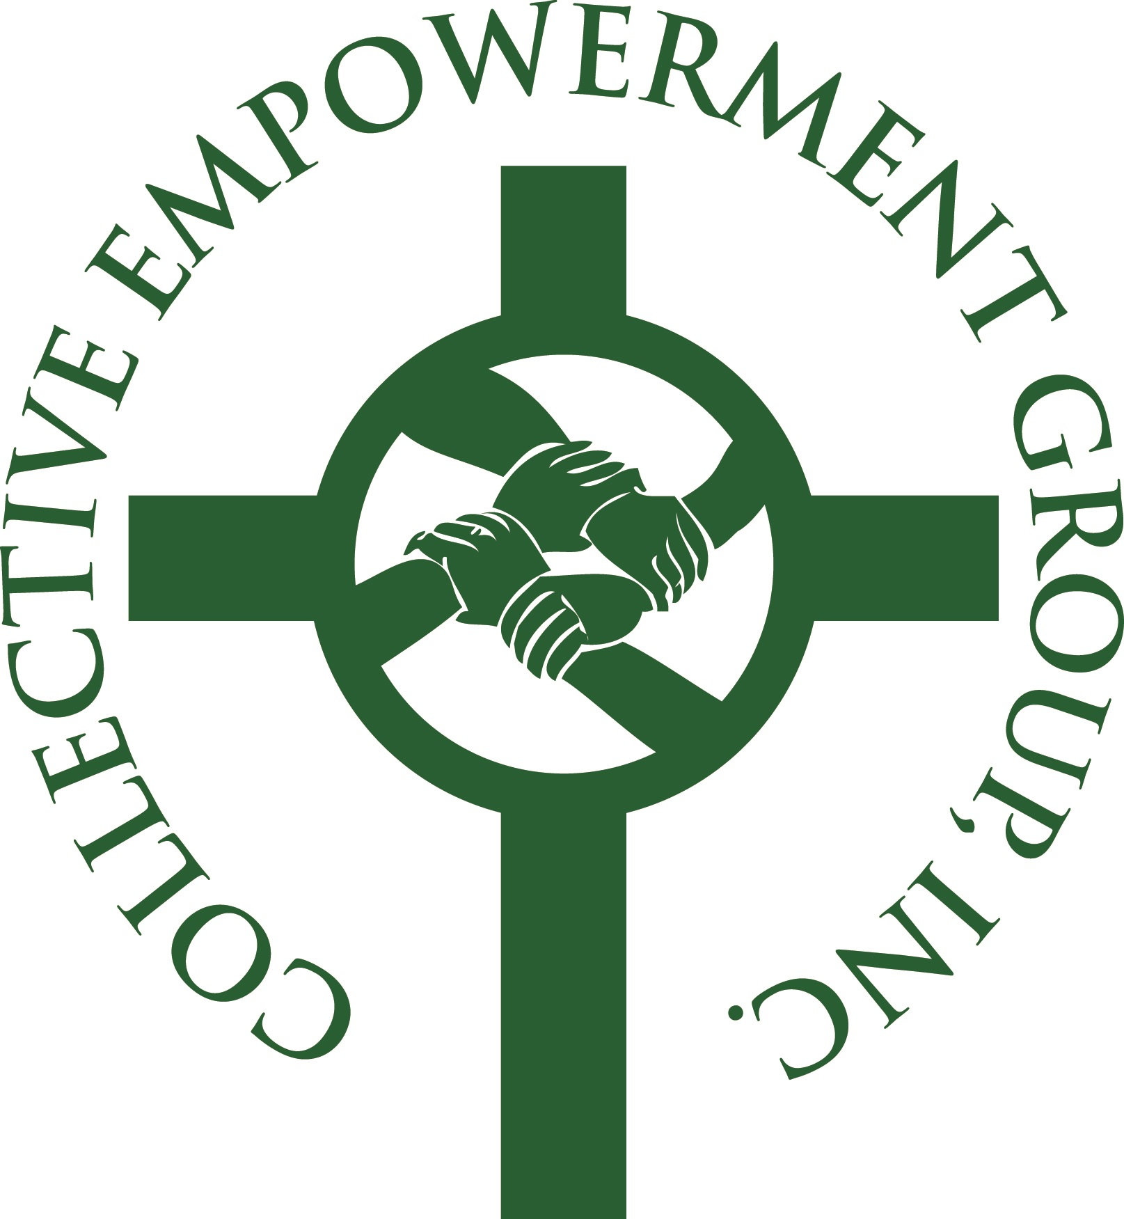
ANNUAL EMPOWERMENT CONFERENCE
Plugged In: Make the Connection with Information through Education
FRIDAY, OCTOBER 3, 2014
8:30a.m. – 3:00p.m.
First Baptist Church of Glenarden
3600 Brightseat Road – Landover, MD

CONFERENCE SCHEDULE
8:30a.m. – 9:00a.m. Guest Registration
Continental Breakfast
Exhibit Hall Opens

9:00a.m – 9:55:00a.m. Opening Plenary
Meditation:
Topic:
Facilitator:

9:55a.m. – 10:00am. Conference Overview
10:00a.m. – 3:00p.m. Grantwriting Seminar
Learn how to write grants and find funders

WORKSHOP SESSION I

10:00a.m – 10:55a.m Leadership/Motivation for Pastors (Pastors)

10:00am. – 10:55a.m. Church Tax Compliance (Church Leaders)
Do you know what laws may affect you? Your ministry, your church, or even your religious liberty? Laws applying to churches change constantly!

10:00a.m. – 10:55a.m. Plugged In: Developing Businesses and Entrepreneurship
and the CEG/CEV (Small Business)
Own a business? Starting a business? Just thinking about it? This workshop is for you!

10:00a.m. – 10:55a.m. To Your Health: Diabetes Control and Prevention (Congregation/Community)
This session features tips and strategies to prevent or control diabetes

WORKSHOP SESSION II

11:00a.m. – 11:55a.m Grief Management (Pastors)

11:00a.m. – 11:55a.m. Taking Care of the Pastor (Church Leaders)
Long Term Care, Retirement Packages

11:00a.m. – 11:55a.m. Funding Your Business (Small Business)
Where is the money? This session is designed to direct you to resources and help you to identify grant opportunities to finance your business.

11:00a.m. – 11:55a.m. Community Development: It’s OK to Buy a House Now
(Congregation/Community)
WORKSHOP SESSION III

12:00p.m. – 12:55p.m. Pastoral and Congregational Leadership (Pastors)
Panelist: Rev. Sinclair Mitchell
Facilitator:

12:00p.m. – 12:55p.m. Senior Assisted Living (Church Leaders)
Help for choosing the right assisted living community for your loved one.
The Residence on Greenbelt, Capital Caring
Facilitator:

12:00p.m. – 12:55p.m. Plugged in to Technology: Harnessing the Power of Technology to Grow Your Business (Small Business)
Panelists: Verizon
Facilitator:

12:00p.m. – 12:55 p.m. Plug In To CEG Benefits (Congregation/Community)
Reinvesting in our communities
Panelists: Marlo Furniture, Capitol Water Investment, Uniquely God Sent, Pohanka Automotive, Residence on Greenbelt, MedStar, Clark Construction
Facilitator: Midgett Parker

1:00p.m. – 3:00p.m. Luncheon and Closing Session
Keynote Speaker
Strategic Partner Introductions
Closing Remarks

09/02/2014

