  The Honorees | Ms. Daphne Pallozzi  Established in 1963, Ardmore Enterprises supports over 200 adults with developmental disabilities in the metropolitan Washington area.  www.Ardmore Enterprises.org
 | Mr. Ron Lipford  Arel Architects, Inc. is a multi-disciplined architectural firm, assisting clients with a broad range of professional design and engineering and construction management services.  www.ArelArchitects.com
Bankhead  Landscaping | Mr. Jessie Bankhead  Trustworthy, dependable, quality landscaping services.  JessieBankhead1@gmail.com
 | Rev. Vanetta Brice  Data integrity and accurate results are our highest concerns. We are consistently trained in all the latest financial software packages, including QuickBooks, Peachtree, PowerChurch, and EasyACCT.  www.BriceAccounting.com
Charlies T-Shirts | Mr. Charles Williams, Sr.  Quality, creative t-shirts for all occasions  301-390-7734
Under the Hood    Auto Service | Mr. Charles Thompson, Jr.  Auto Body Shop · Car Wash & Detailing ·  Automotive Repair  301-541-0813
 | Mr. Bobby Brown  If you are looking for an experienced design team that can take your company step by step through all process to find – or refine – your voice and visualize it through all aspects of your marketing communications, you have just met your new partner.  www.MakoGraphix.com
Christian Media Consultants   | Ms. Frances Middleton  Christian Media Consultants provides branding and media services to pastors, ministers, churches, non-profit organizations and Christian businesses and schools in the Washington metro area.  Info@ChristianMediaConsultants.net
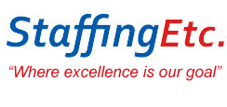 | Ms. Hope M. Porter  Staffing Etc. specializes in placing health care professionals and administrative staff on assignments at government agencies, hospitals, school systems, health centers and private corporations.  www.Staffingetc.net
S&J Ventures | Ms. Sallie Mitchell  Ms. Mitchess provides a myriad of services including embroidery garments, real estate investing, tax preparation and vitamin and wellness consultant.  202-549-4455
 | Ms. Marilyn Dawson  Offering the best and most relaxing services in Bowie, with soothing sounds, caressing aromas and healing hands.  www.SpecialCareSpa.com
 | Ms. Necole Parker  A 8-(a), certified, women-owned business, Elocen is a full-service program management firm providing professional support for lease acquisition, space planning, design/construction management, tenant representation, and relocation/move management.  www.ElocenGroup.com
 | Rev. Thomas Ellis  Transportation is our business  Safety is our #1 Concern  TomsCoachTravel.com
 | Mr. Roger Habersham  A full-service professional company that designs, rebuilds or remodels homes in the Washington metropolitan area.  Roger.Habersham@verizon.net
Mr. Ron Taylor
The Taylor Family of Funeral Homes ministry mission is to provide a service that is life-giving, hope-building and Christ-filled.
Ron@TaylorFuneralHome.com
 | Mr. John Deadwyler  Mr. Deadwyler has found great fulfillment offering encouragement, guidance and resource direction to chronically unemployed residents in Prince George’s County.
 | Mr. Steven and Mrs. Tojuana Whitley  The owners provide Southern-style cooking. Mr. Whitley has created a sauce for use on pork, beef, poultry and fish. It is also a great sauce that can be used on veggies for vegetarian food lovers.  www.DivineTasteCateringLLC.com
 | Ms. Kim Rhim  The Training Source offers a variety of services that greatly enhance skill sets. We develop people not just skills.  www.TheTrainingSource.org
Sew Exquisite   | Ms. Joyce Jackson
 | Ms. Romunda Ings  For more than 15 years, Ms. Ings has successfully assisted hundreds of clients to enhance their quality of life by helping heal the mind, body and spirit.  www.cleanseyourcolon.com
 | Ms. Mileah Perrin  Opened in 2009 with a very simple mission, “to be the ideal childcare center for your family.”  www.IdealChildcare.org
 | Ms. Tamara Chisim  Innovative Element is a minority-owned, woman-owned, IT firm. The team of credentialed professionals has more than 25 years of government contracting experience.  www.Innovative-Element.com
 | Ms. Jackie Foster  Everyone Loves Ritas!!!  www.facebook.com/iloveritas
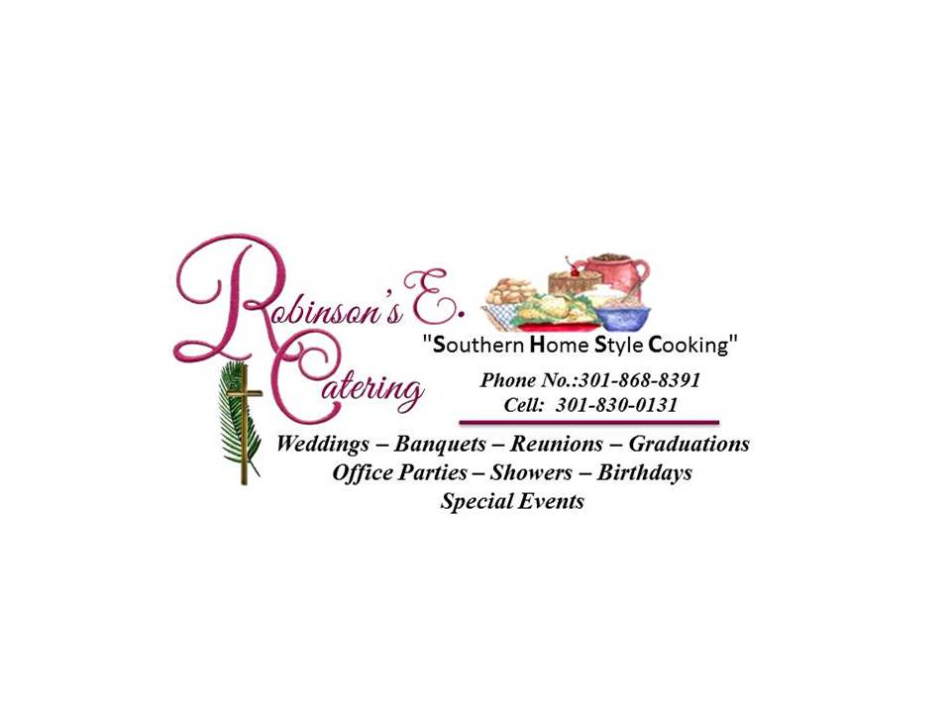 | Ms. Elaine Robinson  “Southern Home Style Cooking”  301-868-8391
 | Ms. Quianne Perrin  FlyCandy Media is a Clever Communications Agency, specializing in highlighting the lifestyle and entertainment industry.  www.FlyCandyMedia.com
Russells Trimlawn and Landscaping   | Mr. David Russell  No matter what you need help with -- mowing, trimming, pruning, grading, sodding, planting, seeding, edging, mulching and more -- our number one goal is to delight you with our landscape service so that you want us to keep helping you year after year!  Russell’sTrimlawn.com
With These Hands   Interpreting Services | Ms. Yvonne Robinson
Creative Ventures, Inc. | Dr. Arnold Howard  Creative Ventures has been instrumental in developing entrepreneurial businesses for the returning citizen population in the state of Maryland.  CreativeLinkCoalition.com

